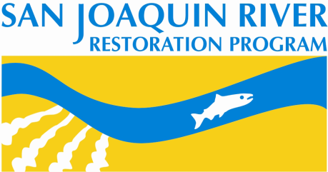
Bureau of Reclamation
2800 Cottage Way, MP-170
Sacramento, Calif. 95825-1898
Realty Agreements
Frequently Asked Questions

GENERAL PROGRAM QUESTIONS
The following questions are frequently asked by landowners and the answers below may be useful to you.

Does the San Joaquin River Restoration Program (SJRRP) have money for acquiring land or easements, and what happens if the SJRRP doesn’t get additional money appropriated?
The SJRRP has $88 million in funding from the San Joaquin River Restoration Fund provided by Congress in 2009 that is not subject to further appropriation. The SJRRP may begin spending the rest of the San Joaquin River Restoration Fund in 2019 (estimated at about $225 million) without further appropriations. All other funding sources are subject to appropriations. The long-term operating budget of the program will be around $5.2 million per year, with up to $2 million per year from Central Valley Project Improvement Act, and approximately $3.2 million per year from Friant surcharge receipts.

Current priorities are to release flows and construct the Mendota Pool Bypass. Reclamation has money in its fiscal year 2017 and 2018 budgets allocated to the SJRRP and to the purchase of easements and land.

What has the Program done to address potential groundwater seepage impacts to crops?
The goal of SJRRP’s Seepage Management Plan is to maximize flows in the San Joaquin River and Eastside Bypass while avoiding material adverse groundwater seepage impacts. Two main crop impacts could occur from the SJRRP’s flows: waterlogging and/or root-zone salinity. The Seepage Management Plan includes a program of monitoring wells (we have installed more than 200 wells during the past 4 years). We have set groundwater level thresholds in these monitoring wells, and do not allow river (or Eastside Bypass) flows to increase to a level that would cause the groundwater in the well to rise above the threshold. Currently, flows into the Eastside Bypass will be held at approximately 300 cubic feet per second (cfs) due to groundwater thresholds in wells in lower Reach 4A. Once seepage easements or projects are completed, flows will gradually increase.

While holding flows low, we are working on solutions (such as seepage easements) with the adjacent landowners to allow higher flows. We have prioritized areas along the San Joaquin River based on their likelihood for groundwater seepage impacts, from an elevation perspective. When the water surface elevation in the river is higher than the elevation of the field ground surface outside the levees, there is a high probability of seepage. Most seepage prone areas are within 1/4 to 1/2 mile from the river based on modeling information and information provided by landowners. We are working to find permanent groundwater seepage solutions for the landowners with a high seepage potential first. Then we will be moving on to lands with a lower seepage potential, and gradually increase river / bypass flows accordingly.

Can I divert SJRRP flows?
The Settlement in NRDC et al., v. Rodgers et al. (Settlement) outlines a program of flow releases, termed Interim and Restoration flows. Under Paragraph 13(h) of the Settlement, Reclamation is required to manage and control all Interim and Restoration flows from Friant Dam to the Sacramento-San Joaquin Delta and undertake all reasonable measures to protect the rights to manage and control these flows, including initiating appropriate enforcement proceedings to prevent unlawful diversions of, interference with, or taking of these flows. For this reason, Reclamation petitioned the State Water Resources Control Board (State Board) to protect these flow releases dedicated under California Water Code Section 1707. On October 21, 2013, the State Board issued an amended Water Rights Order that permanently protects these flows. The Order provides for changes to the points of diversion, places-of-use and purposes-of-use, and protection of flows from unauthorized diversions. These flows may not be diverted without Reclamation’s authorization.

Under the Order, Interim and Restoration flows are waters previously stored under Reclamation’s appropriative water right permits in Millerton Reservoir and released for instream purposes and for rediversion at specific points, or waters diverted at Friant Dam and subsequently remaining under dominion and control in the river channel. These storage release flows are foreign in time and not abandoned, surplus, or natural flow waters, nor are they flood flows. Riparian water rights apply only to the water which would naturally flow in the stream. Therefore, riparian water right holders do not have a right to divert the SJRRP’s dedicated storage releases. Nor do riparian water rights holders have a right to divert SJRRP’s dedicated flows that were otherwise taken under dominion and control at Friant Dam.

Can landowners divert flood flows?
Landowners may be able to divert flood flows if they have a valid water right. If requested, the SJRRP can notify landowners of the amount of Restoration Program flows we expect at different gaging stations. This amount would be protected under Reclamation's appropriative water rights and would not be available for diversion.

What are the expected SJRRP Flows?
SJRRP flows for the next several years will be kept low due to groundwater seepage concerns in Reach 4A (Sack Dam to Washington Road). Gradually, as seepage easements or projects are completed, flows will increase. Figure 1 below shows the default flow releases expected into Reach 2B, Reach 4A, and the Eastside Bypass by water year type in the long term. The Restoration Administrator can change the flow schedule during the spring and fall pulse periods (hatched areas on the graph below).
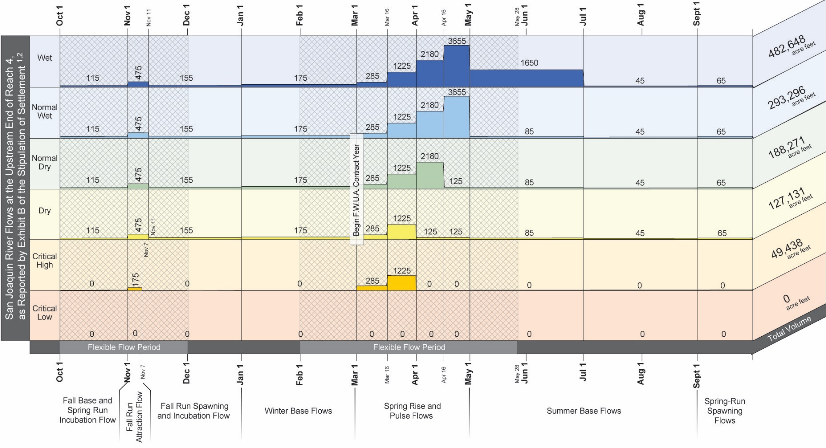
REALTY AGREEMENT TERMS

Would landowners need to add the United States as an insured on their insurance due to the SJRRP's use of the property?
You are not required to do so, but may opt to if so desired.

Can both parties mutually indemnify in the agreement?
No. Reclamation cannot agree to indemnify as this would be a violation of the Anti-Deficiency Act. Federal agencies cannot indemnify anyone unless they have explicit legislation authorizing them to do so on a case-by-case basis. The SJRRP legislation does not provide such authority. Should someone believe they have been harmed they have recourse under the Federal Tort Claims Act (FTCA) and depending on the nature of the claim there may be other administrative remedies.

Can payment for a realty agreement be made later than the signing of the agreement?
Yes. Reclamation would like to finalize and record the agreement as soon as possible. However, it will take some time to open an escrow account, obtain title insurance, and other necessary activities. We would be fine with making payment at a time that you specify as long as the agreement is executed on time.

Can Reclamation do a Section 1031 exchange?
Reclamation cannot provide tax advice. In the past Reclamation has worked to provide payment in a timely manner such that landowners can pursue a 1031 exchange of their own volition.

What is the realty process?

Key Appraisal Steps include:
- Submit request to Office of Valuation Services (OVS) for writing a scope of work (2 months)
- Reclamation contracting awards interagency agreement to OVS to complete and review appraisals (1 week)
- OVS goes through internal contracting to submit a Request for Proposal (RFP) or sole source to an appraiser and awards a contract for the appraisal (3-4 months)
  - OPTIONAL: The landowner may hire the appraiser directly, from a list of OVS approved appraisers. This reduces the timeframe by 2-3 months.
- Appraiser reviews comparable properties, background info (1 month)
- Appraiser conducts site visit with landowner (2 weeks)
- Appraiser finishes appraisal (2 months)
- OVS reviews appraisal and writes review report (1 month)
- Appraiser revises appraisal based on any questions or concerns from OVS (2 weeks)
- OVS 2nd level reviewer reviews appraisal and review report (1 month)
- Appraiser revises appraisal based on any questions or concerns from the 2nd level OVS review, if applicable (2 weeks)
- OVS accepts appraisal as meeting Federal standards and finalizes its review report (2 weeks)
- OVS sends the appraisal to Reclamation
- Reclamation provides written offer to the landowner (1 week)
- Reclamation negotiates purchase with landowner (1-5 months)
- Once negotiations are successful, Reclamation orders final title report (1 week)
- Solicitors Office reviews title and prepares opinion, if necessary (2 weeks)
- Reclamation signs agreement, records document and takes possession of land/easement (3 weeks)
- Reclamation sends payment voucher to our Denver finance group to process (1 week)
- Reclamation’s Denver finance group transmits funds in an electronic funds transfer to an escrow account, if necessary (2 weeks)
- Reclamation authorizes payment to landowner and landowner is paid
Concurrent Steps
- Reclamation conducts an Phase 1 Environmental Site Assessment for hazardous materials (3-4 months)
- Reclamation orders preliminary title reports from a title company (1 month)
- Reclamation writes legal descriptions for parcels based on title reports (2 months)
- Reclamation completes a National Environmental Policy Act categorical exclusion (2 weeks)

