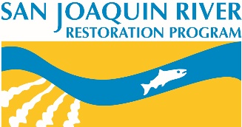 | San Joaquin River Restoration Program Science Meeting  Abstract Submission Form - 2018
General Information
Poster/Presentation Title: Click here to enter text.
Presenter: Click here to enter text. |  | Affiliation: Click here to enter text.
Phone Number: Click here to enter text. |  | Email Address: Click here to enter text.
Collaborating Authors, with affiliation: Click here to enter text.

☐ Poster Presentation ☐ Pop-up talk (5 minute quick presentation) ☐ BOTH poster and pop-up talk
Abstract (500 words or less)
Click here to enter text.
Optional – graphic from poster for inclusion in abstract book

