Pixley/Delano-Earlimart Joint Ground Water Bank

The Delano-Earlimart Irrigation District (ID) and Pixley ID have proposed to develop the Pixley Groundwater Bank (Project). The Project includes a new turnout from the Friant-Kern Canal, 4.5 miles of pipeline for the delivery and recovery of water for the Project, and pumping plants and associated electrical and control facilities to boost water recovered from the Project. The Project also includes 575 acres of recharge basins with a well field of 11 recovery wells. The recharge basins are estimated to have a recharge capacity of 45,000 acre feet (AF) per year and a recovery capacity of 25,400 AF. The Project will also bank groundwater through in-lieu service to 2,200 irrigated acres, with a recharge capacity of 6,500 AF per year. The recovery wells in the in-lieu service area will have a recovery capacity of 8,500 AF. The Project area is shown in Figure 1.
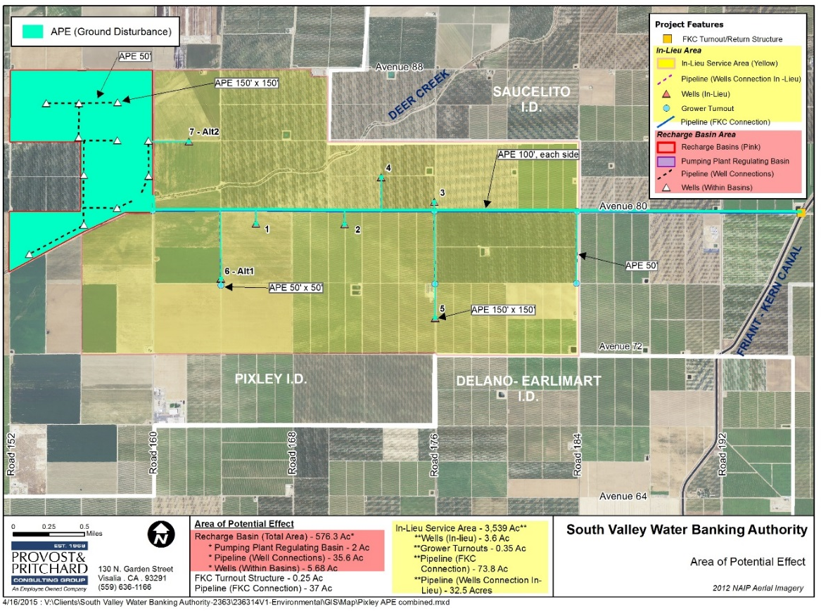
Figure 1. Project Site Map
The Project has an estimated total cost of $17,400,000, with a Federal cost share funding of $7,500,000.
The long-term RWA reduction is estimated at 97,218 acre-feet. There is a total of 30,000 shares in the Project, with 15,000 shares targeted for development with Part III funding. A requirement to purchase these 15,000 shares is that RWA balances from a long-term Friant Division Contractor will be reduced by any water supplies banked under these shares.

